# MGT1022- Lean Start-up Management

**DIGITAL ASSIGNMENT-4**

**ALOKAM NIKHITHA (19BCE2555)**

**TE1 Slot**

**Business idea : Food waste disposal in a smart way**

**Motivation**

We often find that there would be a lot of wastage in Universities which includes food plastic and various other forms of wastages. Students often waste food in the canteens and Hostels. Not just the students we can see that many restaurants produce a lot of food wastage daily. And this wastage is disposed in various ways. The main reason for choosing this business idea is to change the way how this waste is being disposed .

**Aim / Objective**

The main aim is to provide waste management solutions .The core product line's goals include composting food waste and supplying alternative fuel alternatives and manure to organic farmers and restaurants. We also have large-scale waste management and energy producing initiatives for society/housing. Recycling and decreasing when and where it is needed, this business wants to provide a wide range of products and services to make garbage disposal more desirable and rewarding.

## **Risk /Opportunity**

* Among the issues of market penetration and customer retention, one of the key bottlenecks to our operations is the problem of a relatively untapped market and an uninformed client base.
* However, the raw potential of the food and beverage sector, which has a huge client group that requires waste management solutions and alternative energy sources for their operations. Coupled with this, the increase in public awareness of environmental issues and consumer knowledge of organic produce is a crucial reason encouraging the market to use our service.

## **Products and services**

Our product is a trash decomposer that is biodegradable. Kitchen waste will be disposed of in the decomposer. Enzymes are utilized within the decomposer to digest this trash under optimal circumstances defined by the software installed on each bin. As a result of the biodegradable waste, organic manure is produced. Farmers can use this instead of chemical fertilizers in their crops for cultivation purposes. This technique can also produce a harmless fuel supply. The decomposer is a fully automated device.

**Business Plan**

The product will be produced on a small scale and sold to 5 big restaurants in Vellore and hostels in VIT. The obtained manure is collected by the enterprise and sold to farmers in the neighbouring village area via the government. Based on the operation of the compost bin, the enzyme was altered and made more easily and conveniently useable with a shorter time period for composting. To achieve optimal productivity, the programme was additionally upgraded, tweaked, and tested. The collected manure was analyzed for hazardous substances. More digitalized methods for testing the pH and other parameters of the generated manure are being developed. The success rate is reviewed on a regular basis, and improvements are made.

## **Market Size and Trends**

Full-service restaurants have the biggest market share in India, accounting for 57 percent of total sales. QSR is the next largest segment, accounting for approximately 16% of total sales.

Given the country's vast array of cultures and cuisines, it's not surprise that almost two-thirds of the restaurant units are loosely structured, small, independent eateries—dubbed "unorganized"—that frequently double as retail grocery stores. Only approximately 2% of total restaurant inventory is branded, which is less than a tenth of what is observed in other nations with a more developed foodservice industry.

However, this is changing. As more international, national, and regional firms enter the market, the emphasis shifts toward more chain-affiliated and standardised operations. A value-seeking mentality (which is to be expected, given that the median family income in 2015 was approximately USD 4,000), marketing, more mobility, and social media will all fuel increased demand for QSRs.

Given the country's vast array of cultures and cuisines, it's not surprise that almost two-thirds of the restaurant units are loosely structured, small, independent eateries—dubbed "unorganized"—that frequently double as retail grocery stores.

Only approximately 2% of total restaurant inventory is branded, which is less than a tenth of what is observed in other nations with a more developed foodservice industry.

However, this is changing. As more international, national, and regional firms enter the market, the emphasis shifts toward more chain-affiliated and standardised operations. A cost-effective

Seeking mindset (which is to be expected, with median household income around USD 4,000 in 2015), marketing, increased mobility, and social media will all fuel increased demand for QSRs.

In India, chains outperform smaller operators in the fast food industry. Chain-affiliated QSRs outperform independents in terms of sales per outlet, with chain transactions average USD 2.29 versus USD 0.90 at independents. Many domestic providers will need to update and standardise their operations in order to remain competitive as the market heats up.

**MARKETING PLANS & SALES STRATEGY**

**Marketing Strategy**

* ***Attractive Tele commercials*** - We're preparing to shoot a commercial with a well-known television personality that we can afford with our marketing budget. This might be broadcast on Naaptol to promote the product.
* ***Customer selection*** - For a small or medium-scale organic farmer, NaturePLUS will be a very useful tool. Our main aims are restaurants with more than three stars, such as Holiday Inn and Marriott, as well as organic eateries in Bangalore, such as Rasa India, Green Theory, and Om Made Café. In addition, a SHG dedicated to growing organic veggies expressed interest in purchasing our manure bin for waste from their cattle fields.

Our retail stores will be located near parts of the city with a lot of restaurants, making it convenient for customers to get about. It would also be beneficial to establish a platform near a colony of organic farmers.

* ***E-mail campaign*** - Create a regular email newsletter for subscribers to receive. Discounts, promotional items, and articles/blogs about urban farming, garbage decomposition, and other topics can all be promoted. Open-source input can help to improve the curated material.
* ***Environmental issues and pollution***-related problems will be prominently featured in all kinds of advertising. The importance of taking quick action to address the problems that have already arisen, as well as the stress imposed on nature, will be extensively publicised.
* Images related to business stored on farms and the individuals who use it with ease will be used in websites and advertisements to reach out to more people in the business.
* For the first few clients, there will be discounts and reductions on the bin as well as enzyme packets.

## **Internet Goals and Plans**

The internet is a crucial piece of technology that has been around for several decades. Its reach is expanding to new heights unseen by any other technology. Because of the presence of the internet, the product is capable of all forms of communication. All of the sensors will gather information about their surroundings and transfer it to the cloud for storage and Big Data analytics. Certain algorithms will be able to calculate the fundamental values that the client will need to know. These include:

1. The daily amount of compost produced.

2. Funds raised by selling compost on a weekly/monthly basis.

3. The amount of each enzyme utilised per cycle in order to calculate the weekly/monthly cost of enzymes alone

4. With all of this information, the customer may estimate the weekly/monthly profit they will make by selling the manure they have created.

Aside from technology, the internet will be the main source of advertisements. The internet has a huge reach, and the best part is that we can show our goods to the entire globe for free. Facebook, YouTube, and other social media platforms contribute to such reasons. Facebook now has a user base of over 2 billion people. 2.2 billion users logged into their accounts in the fourth quarter of 2017. If one person shares a post, the average reach will be between 50 and 80 people. Even if only ten of us start the chain and assume a reach of 50 people per person, by the third time the post is shared, around 26000 individuals would have heard about the product.

The product demo video can be shot and uploaded to YouTube. If we use the same algorithm of the ten of us sharing the video to 50 different people, by the third cycle, 26000 people will have seen the video, and if the cycle continues, the video may appear in the trending section of YouTube, and people who are completely unrelated to the sharing chain will tend to increase and may start their own chain.

## **Software Needs**

To build a platform for the automation of the composter unit, the organisation requires customised software services. The user interface (UI) must be seamless and simple to use. The software should be able to generate error logs and keep them in memory.

## **Hardware Needs**

As previously noted, the list of hardware requirements is rather pricey. As a product-based service, we rely heavily on high-quality, durable hardware.

## **Telecommunications Needs**

If our product is a success, we will need to set up a few call centres throughout the world. To do so, we must choose plans from telecom and internet service providers. We will want a dependable connection, as well as toll-free numbers, so that customers may call us at any time and from any location. An optical fibre connection will be preferred above any other type of connection since it is exceptionally dependable and quick.

|  |  |  |  |  |  |
| --- | --- | --- | --- | --- | --- |
| **Business Model Canvas** | |  | |  |  |
|  |  |  | |  |  |
| **Key Partners** | **Key Activities** | **Value Proposition** | | **Customer Relation** | **Customer Segmen** |
| Supplier and Vendor Parties | Waste management | To provide accessible and reliable waste management  Electronic Recycling or E- recycling  To turn food and yard waste into compost | | Commitment to sustainability – think green | Municipalities  Healthcare Facilities |
| Waste Management Companies | Environmental Engineering | Environmental Protection | Food service Business |
| Partnership with more renewable energy companies | Research and Development  Develop customer relationships | Accessibility Ease of Use | Household |
| Fertilizer/Bioenzyme  markets | Build Brand | Self-service tools |  |
|  | Organic Waste consulting | Dedicated sales personnel |  |
|  |  | Consulting |  |
|  | **Key Resources** |  | | **Channels** |  |
|  | Composting/Enzyme consultant |  | | Website |  |
| Relationships with waste management companies | Online customer Portal  Social Media |
| Financing | Network of Offices |
| **Cost Structure** |  |  | **Revenue Streams** | |  |
| Website and App Development | |  | Subscription Services for ongoing support and branding | | |
| R&D | | Upfront fee for end to enf process | | |
| Network of Offices | | Recycling add-ons/ Enzyme packets | | |
| Machinery | |  | | |
| IoT | |  | | |
| Personnel | |  | | |
| Equipment | |  | | |
|  | |  | | |
|  | |  | | |

**Technology goals**

* To deliver the finest user interface with the product. The stage of development. Utilize the internet of things to integrate smart technology within the product.
* If the programming is done correctly, IOT will allow our product to handle minor faults on its own. As an example, alerting the user about the compost's entire development, the volume of waste produced, and the current level of enzymes.
* Using previously collected data, we can also utilize machine learning algorithms to anticipate the number of enzymes that will be used to generate the compost. The software component is mostly based on SPYDER, which supports Python and has various model libraries that aid in producing graphs, providing precise readings, and predicting all conceivable permutations to provide accurate findings on product usage.
* This unit will house a plethora of sensors such as temperature, humidity, proximity, and infrared sensors, among others. To store and analyse data, these sensors will communicate with one another and with other linked devices. That device could be a hard drive, a cloud service, or even just a memory chip.

**Financial Activities**

## **Income Statement**

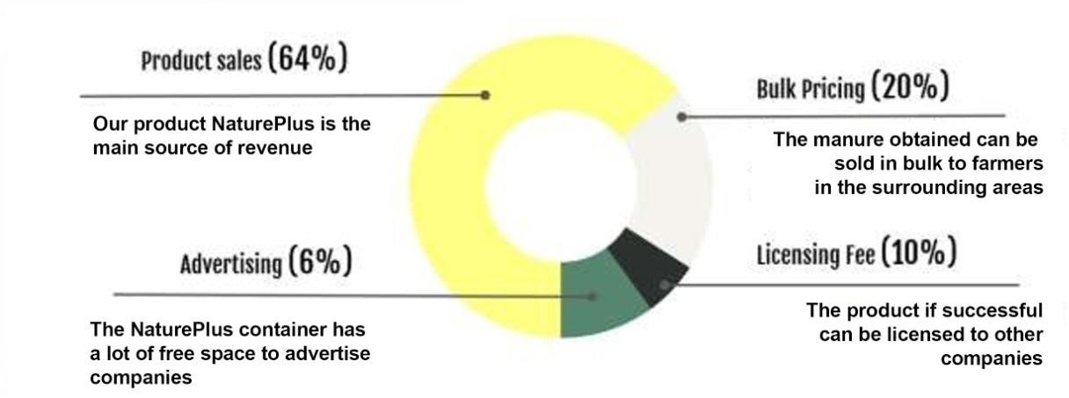

**Cost Estimation**

|  |  |  |
| --- | --- | --- |
| Component/ Equipment | possible suppliers | Amount (per product) |
| Heaters | Elmec Heaters and controllers , indus Heaters, Supreme Industrial Heaters | Rs. 55,000 |
| Monitors | BenQ, LG and ASUS | Rs. 22,000 |
| CO2 detectors |  | Rs. 4,000 |
| Thermal insulations and casings |  | Rs. 1,500 |
| Enzymes | Novozymes, AB enzymes, Aum Enzymes | Rs. 680 per litre |
| Total production cost per unit |  | Rs. 83,180 |

|  |  |
| --- | --- |
| EXPENSES | AMOUNT |
| Building / Real Estate | Rs. 50,000 |
| Location expenses | Rs.10,000 |
| Leasehold improvements | Rs. 5,000 |
| Working Captial | Rs. 12,000 |
| Opening Inventory | Rs. 10,000 |
| Other expenses | Rs. 5,000 |
| Total | Rs. 92,000 |

**Source and Use of Funds**

Funding can be done in different ways. Among the initiatives are:

• VIT TBI

• Indiegogo and Kickstarter

For agriculture-based products, angel investors are also a potential alternative. Anirudh Mullick , Karl Meheta , and Brad Holden are some of the angel investors in our product space. This will necessitate the creation of contingency plans as well as a shift in strategy — VCs are now looking for companies with backup plans and stable cashflows.

• Raw Material Assistance Scheme – Financing purchase of indigenous and exported raw materials

• Rashtriya Krishi Vikas Yojana – Financial support and incubation ecosystem

• Support for International Patent Protection in Electronics and Information Technology (SIP - EIT) – Assistance in international patent filing procedures

• ASPIRE – SIDBI funds and provision of services

**Why do you think that your idea will flourish in the long run?**

With its industrious progress this business aims to educate the populace about the need for environmental awareness and provide a method for farmers to obtain good quality organic manure for a subsidized rate. There would be no stop in the business as there would be continuous food wastage for the disposal and people nowadays are very much interested towards such management schemes and ideas, which can lead to the flourish of our idea on long run.

**Plagarism Report**

First 923 words of the report

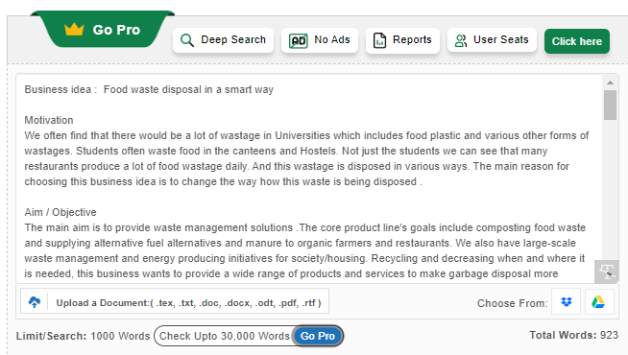

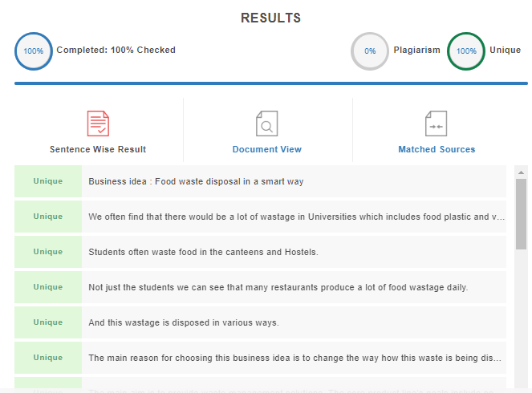

Next 804 words of the document

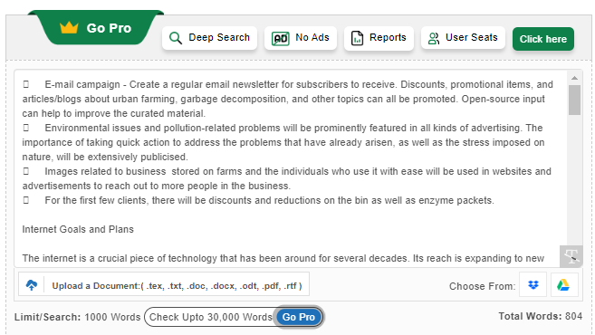 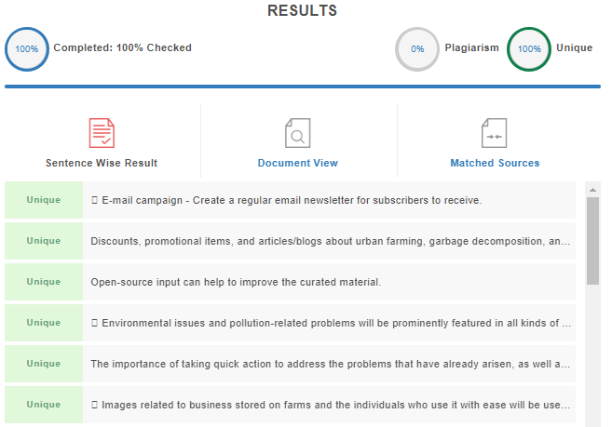

Last 310 words of the document:

